**JSPM’Narhe Technical Campus**

**Master of Computer Applications(MCA)**

**Subject Name:-Mobile Application Development - (IT-31)**

**MCA-I SEM-II**

Practical Assignment

Assignment Declaration Date:- 01/03/2022 Assignment Submission Date:-15/03/2022

Assignment assessment declaration Date by faculty: 01/03/2022

**Solve any five Questions**

|  |  |  |  |  |  |  |
| --- | --- | --- | --- | --- | --- | --- |
| **Q.No** | **Question Statement** | **Level of Mapping & Number** | | | **Blooms Level** | **Marks** |
|  |  | CO | PO | PSO |  |  |
| 1 | Write an android code to make phone call using Intent | 2 | PO-2 | PSO-1 | 1 | 10 |
| 2 | Demonstrate different Layouts with different views in android LayoutsConstraint Layout, Relative Layout, Table Layout Views- Button, Text View, Edit Text, Web View, CheckBox, RadioButton, ToggleButton, ImageButton, RatingBar, ProgressBar, SeekBar, VideoView, DatePicker, CalendarView, Spinner | 1 | PO-2, | PSO-1 | 6 | 10 |
| 3 | Demonstrate Array Adapter using List View to display list of fruits. | 2 | PO-2 | PSO-2 | 5 | 10 |
| 4 | Write an android application using SQLite to create table and perform CRUD operations (Example. COURSE table (ID, Name, Duration, and Description), perform ADD, UPDATE, DELETE and READ operations) | 4 | PO-1,  PO-3 | PSO-2 | 3 | 10 |
| 5 | Demonstrate Options Menu, Context Menu and Popup Menu in android | 3 | PO-2  PO-3 | PSO-1 | 2 | 10 |
| 6 | Create a fragment that has its own UI and enable your activities to communicate with fragments. | 3 | PO-2  PO-3  PO-12 | PSO-1 | 4 | 10 |
| 7 | Demonstrate Array Adapter using List View to display list of fruits. | 4 | PO-2  PO-3  PO-12 | PSO-1 | 4 | 10 |
| 8 | Write an android code to turn ON/OFF Bluetooth | 4 | PO-1  PO-3 | PSO-2 | 3 | 10 |

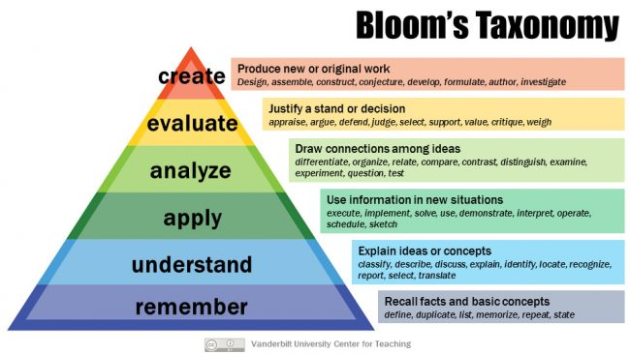

**Subject In-charge Dean**